OudhTrade
Backend Technical Design
Module 1 — Platform Foundation · M01-3
Document details
Company | MRIDA INFRA AND PLANTATIONS LLP
Product | OudhTrade — oudhtrade.com
Document | M01-3 Backend Technical Design
Module | M01 Platform Foundation (release R1)
Readers | Backend developers, DevOps, tech lead
Related documents | PRD (PRD-FND, PRD-CMP) · HLD · other M01 documents
Owner | Tech lead
Decision owner | T. Satish Reddy, CEO & Founder
Status | Draft for review — 24 September 2026
Classification | Confidential — for partners and the OudhTrade team

Contents
1. Overview 2
2. File & Media Pipeline 4
2.1 File states 6
3. Internal Interfaces 7
4. Public API Endpoints (v1) 8
4.1 API rules for all modules 9
5. Events and Jobs 10
5.1 Events Module 1 reacts to 10
6. Audit Log Design 11
7. Units, Locale and URL Details 11
8. Configuration, Security and Performance 12
9. Environments and Pipeline 13
9.1 Backups, standby and disaster recovery 13
10. Rate Limits 14
11. Edge Security Design 15
12. Country & Currency Design 15
13. Threat Model (STRIDE) 15
14. AI Gateway Design 16

1. Overview
Module 1 is a set of shared services inside the Core API and the workers (HLD Section 4). Other modules call them through small internal interfaces; they never access the 33 Module 1 tables directly (M01-5). The backend language and framework follow the team’s approved technology proposal (HLD 13.2).
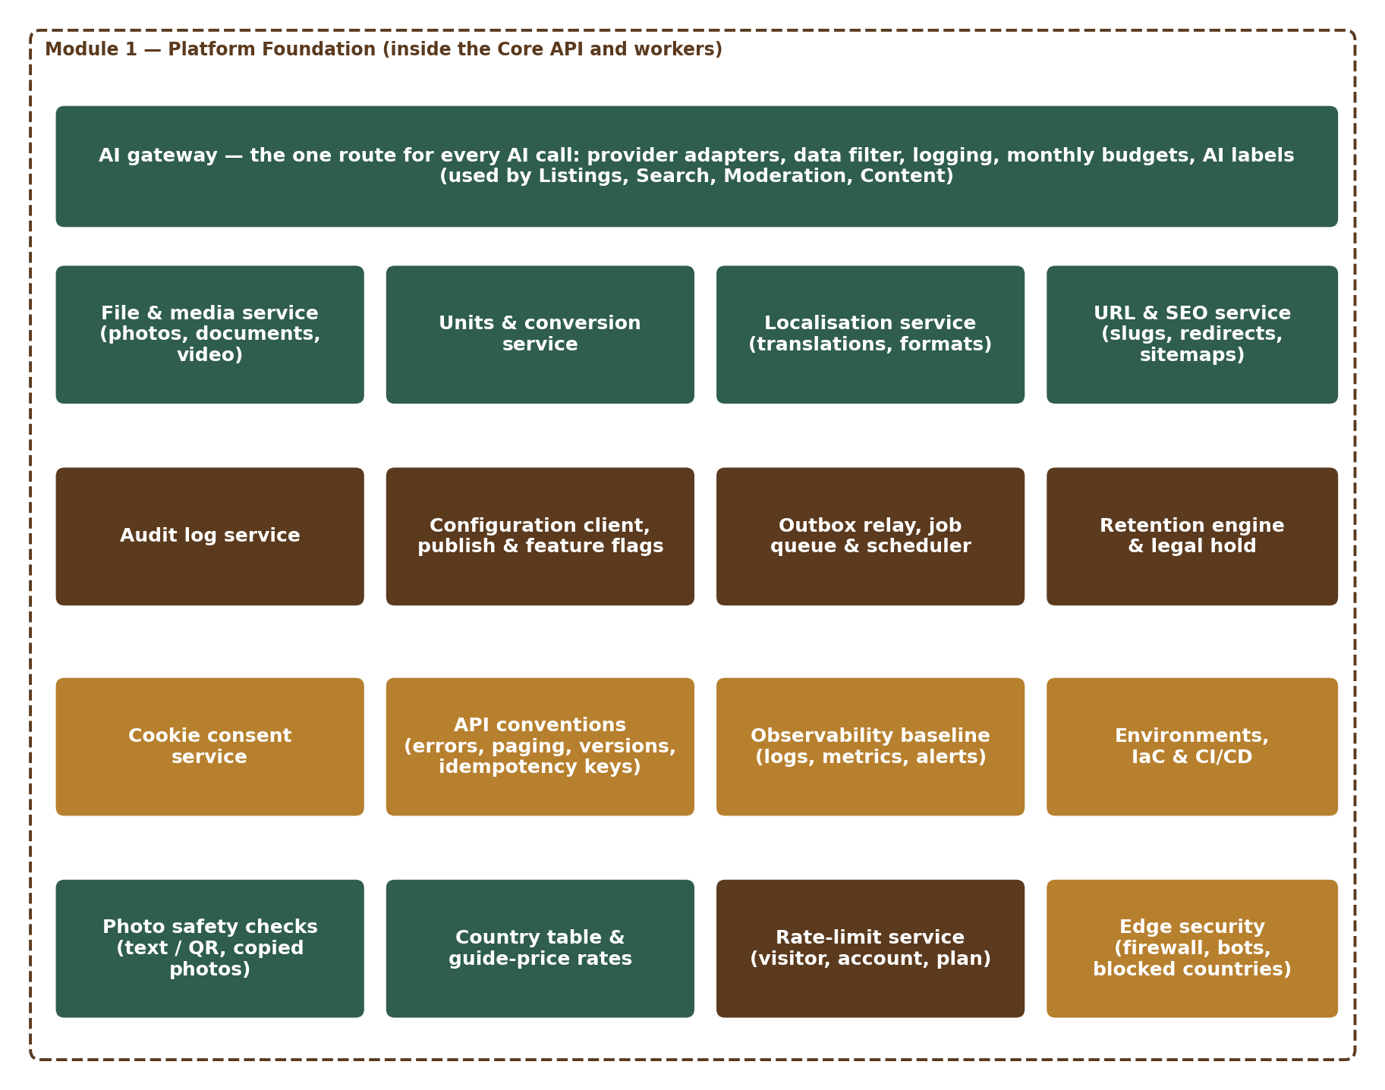
Figure 1 — Module 1 services
Service | Responsibility | Runs in
FileService | Upload slots (pre-signed POST with size limit), quarantine, scan, variants, signed links, attach / detach, moderation decisions, cleanup | API + worker
MediaService | Photo conversion (HEIC→JPG, WEBP) and document conversion (HEIC / HEIF / WEBP → JPG for reviewers) with decode limits, resize, location-data removal, watermark; video checks, 720p conversion, cover image | Worker
ImageSafety | Text and QR-code detection in photos and video covers; photo fingerprints and copy matching; block list | Worker
UnitService | Unit list, conversions, state area factors, price-per-standard-unit | API (cached)
LocaleService | Translations, number / date / currency formatting, phone and address formats, trade-term word list, IST business-hour calculator with holiday calendar | API + web
CountryService | Country table, states / regions, country status and feature rules, daily exchange rates, guide price | API (cached) + worker
RateLimiter | Shared limits per visitor, account, plan and action group; rate-limit headers; blocks and security events | API (Redis)
UrlService | Slugs, store-name checks (reserved names), redirects, sitemaps, indexing rules | API + worker
AuditService | Write, hash-chain sealing and daily check, search (role-scoped), safe export, nightly archive | API + worker
ConfigClient & ConfigService | ConfigClient: read versioned configuration and feature switches with cache and defaults. ConfigService: preview impact, publish (now or scheduled) and roll back approved versions (called by the Configuration Console, M16), version history, export / import | All · API
EventBus (outbox) | Write events in transaction, relay, handler registry, idempotency | API + worker
JobRunner & Scheduler | Database-backed jobs, retries, dead-letter list and staff re-run, timed tasks | Worker
RetentionEngine | Retention policies, daily job, anonymisation, legal holds | Worker
ConsentService | Cookie consent records, account-level choice, cookie-free KPI counters | API
AIGateway | The one route for every AI call: provider adapters, data filter, logging, budgets, output labels (Section 14) | API + worker
Platform middleware | Request ID, error format, idempotency keys, rate-limit check and headers, security headers, pagination, version routing and deprecation headers | API
Edge (infrastructure) | CDN, web application firewall, bot control, geo-blocking of blocked countries, denial-of-service protection | AWS edge

2. File & Media Pipeline
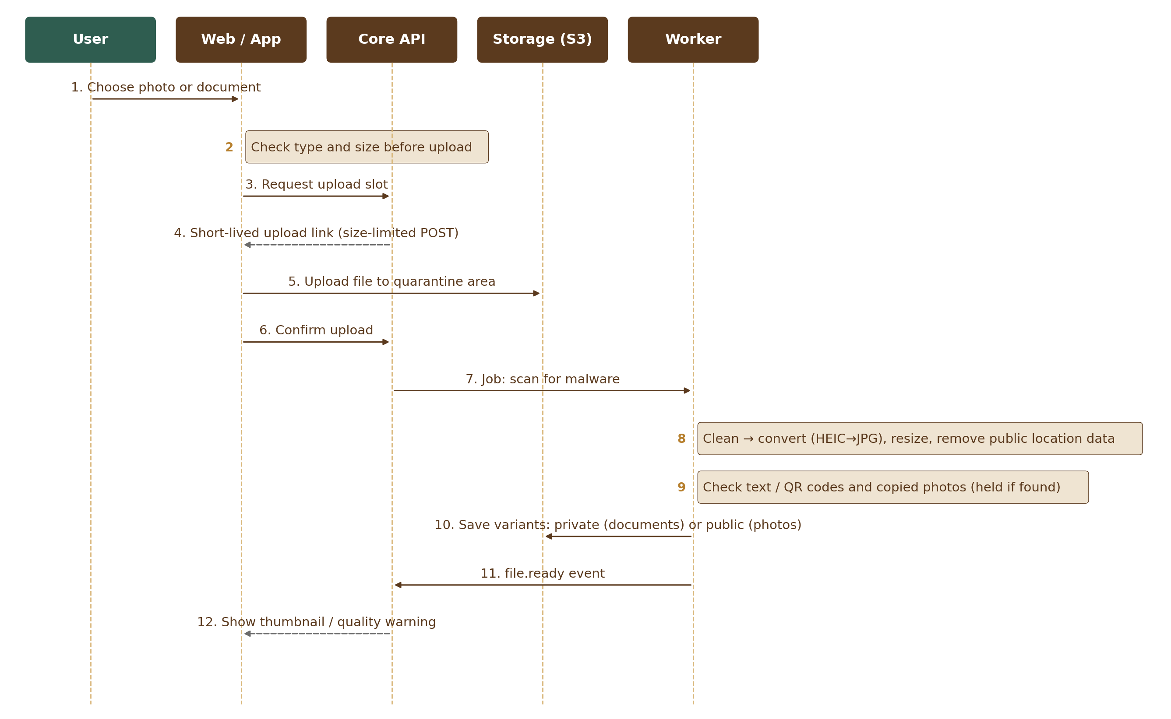
Figure 2 — Photo and document upload sequence
- Direct-to-storage upload (SEC-011): the API issues a short-lived pre-signed S3 POST for one object key in the quarantine prefix (`quarantine/{fileId}`). The POST policy carries a `content-length-range` condition set from the purpose’s size limit (listing photo 15 MB, document 10 MB, video 100 MB, business location video 3 MB — all settings) and the expected content type, so storage itself refuses a larger file. The file never passes through the API server. Video uses multipart upload with resume; the declared size is checked before part links are issued and the real size again at the confirm step.
- Unconfirmed uploads: an S3 lifecycle rule on the quarantine prefix deletes objects 24 hours after upload; the hourly `uploads.cleanup` job marks slots that were never confirmed as `expired`.
- Confirm step: client calls `POST /v1/files/{id}/complete`; API checks size and type (magic bytes, not only extension) and enqueues `file.scan`.
- Scan: ClamAV worker scans the object; clean → `file.process`; infected → object deleted, file marked `rejected_infected`, audit record written.
- Decode limits (against decompression bombs): the worker reads the image header first and refuses images above 40 megapixels or 12,000 px on a side (starting values, configurable) before decoding; decoding runs in a separate process with a memory cap (1 GB) and a time-out (HEIC 15 s, other formats 10 s; starting values, tuned in load tests). A refused image is marked `failed` with reason `image_too_large` and the seller sees “This photo is too large to process”.
- Photo processing: decode (incl. HEIC), keep EXIF/GPS only in the private original, strip it from all variants, auto-orient, create variants (thumb 320, medium 800, large 1600; WEBP + JPG), optional watermark on public variants, quality score (size + blur).
- Photo safety: text detection (OCR) and QR-code reading on the medium variant and on video cover images; patterns for phone numbers (all countries), email, UPI ID and web addresses; a hit sets status `held` and emits `file.held` (reason: contact details or QR code) for Module 12. A perceptual fingerprint (64-bit pHash) is stored per photo with four 16-bit bands for fast search (M01-5 Section 2.1); a match within a configurable distance against another seller’s photo emits `file.held` with reason `duplicate_suspected` — the photo stays visible and Module 12 reviews both listings; block-list matches are rejected. Tool choice (self-hosted OCR / QR libraries or a managed service in Mumbai) is part of the team proposal.
- Moderation decisions: Module 12 never calls FileService directly. Its decision arrives as the event `moderation.file_decided`: approve → `ready` (video live); reject → `rejected` with reason; copied, stock or banned photos are also added to `image_blocklist`.
- Documents: accepted as PDF, JPG, PNG, HEIC / HEIF or WEBP (FIL-008). After the scan, HEIC / HEIF and WEBP documents are converted to JPG (same decode limits as photos) so reviewers can open them in the viewer; the original is kept privately. Stored in a private bucket; access only by `GET /v1/files/{id}/link` returning a signed URL valid 5 minutes (configurable); each call audited.
- Video processing: probe duration and codec; reject > 60 s or > 100 MB; transcode to H.264 720p (≈ 1.5–2 Mbps) + AAC, generate poster frame, strip metadata; status `in_review` and event `file.held` (reason: video review) for Module 12. Transcoding by AWS Elemental MediaConvert or an FFmpeg worker (team proposes).
- Cleanup: the scheduled job deletes uploads never attached after 7 days (status `deleted`); unconfirmed quarantine objects are removed by the lifecycle rule after 24 hours (status `expired`).
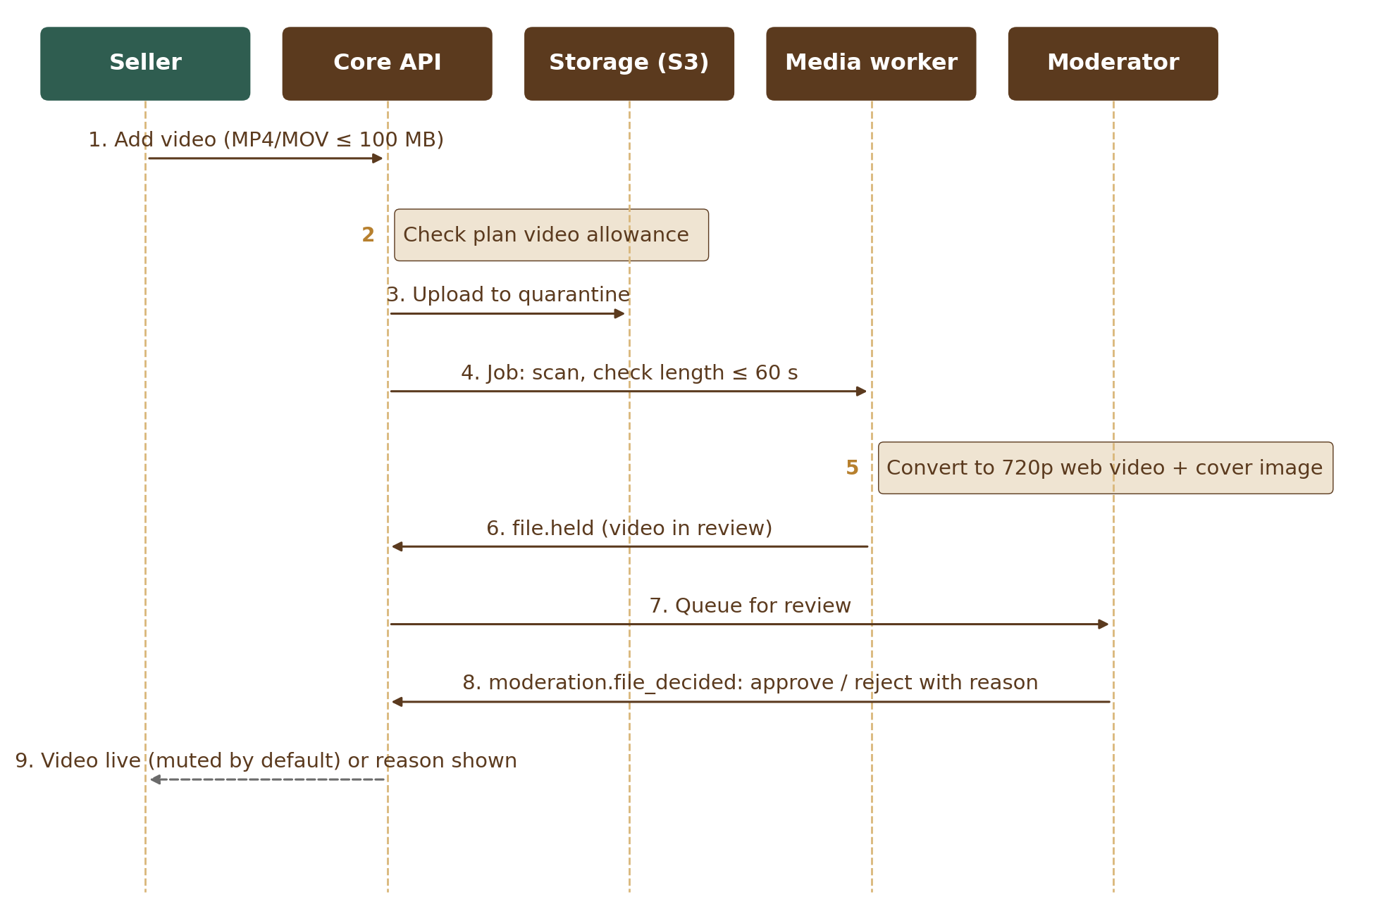
Figure 3 — Listing video sequence

2.1 File states
These are the values of `files.status` (M01-5 Section 2.1).
State | Meaning | Next
pending_upload | Slot issued, file not yet uploaded | uploaded / expired
uploaded | In quarantine, waiting for the confirm step | scanning / expired
scanning | Malware scan running | processing / rejected_infected
processing | Decode limits, conversion and photo safety checks running | ready / held (photo) / in_review (video) / failed
held | Photo contains contact details or a QR code; waiting for moderator | ready / rejected (moderation.file_decided)
in_review | Video waiting for moderator | ready / rejected (moderation.file_decided)
ready | Usable, not yet attached to a record | attached / deleted
attached | Linked to a record (listing, document, message, profile, page) | ready (detached) / deleted
expired | Never confirmed within 24 hours; object removed by the S3 lifecycle rule | — (row kept for 30 days, then removed)
deleted | Removed by the owner, by the 7-day cleanup of unattached uploads, or after its record was removed (listing.removed, document.deleted, message.deleted, account.closed); objects and variants deleted, CDN copies purged; skipped while a legal hold applies | — (row kept per retention policy)
rejected_infected, rejected, failed | Not usable; reason stored | —

3. Internal Interfaces
Interface | Main operations
FileService | createUploadSlot(owner, purpose, type, size) → file ID + pre-signed POST · complete(fileId) · attach(fileId, entity) · detach · getSignedLink(fileId, viewer) · getPublicUrls(fileId) · getLocation(fileId, staff) (verification permission, audited). Moderation decisions come in through the event moderation.file_decided, not a call.
UnitService | listUnits(itemType) · convert(qty, from, to, state?) · helperPrices(metricPrice, unit, category, viewerCountry) · fromHelper(price, traditionalUnit) → metric price
CountryService | get(code) · regions(countryCode) · districts(regionCode) · status(code) · feature(code, name) · guidePrice(amount, currency, viewer) · ratesAsOf()
RateLimiter | check(group, keys) → allowed / retryAfter · register(module, limits) · block(key, minutes, reason)
ImageSafety | scan(fileId) → clean / held(reasons) · fingerprint(fileId) · findSimilar(fileId) · blockFingerprint(fileId, reason)
LocaleService | t(key, locale, params) · formatNumber(n, style) · formatMoney(amount, currency, style) · formatDate(ts, tz) · businessHoursBetween(a, b) · addBusinessHours(t, hours) (both skip Sundays and business_holidays)
UrlService | slugFor(entity) · checkStoreName(name) (rules, uniqueness, reserved_names) · renameStore(id, name) · resolve(path) → entity or redirect
TradeTerms | upsert(groupId?, term, locale, kind) (called by M04) · retire(id) · synonyms(term) (read by M07)
AuditService | record(actor, action, target, before, after, reason) · search(query, viewer) · export(query, superAdmin) → CSV or JSON (formula-safe)
ConfigClient | get(key, default, context{account, role, plan, category, country}) · flag(name, context) · onChange(key, fn)
ConfigService | previewImpact(draftVersionId) → changes, affected counts, example (CFG-008) · publish(draftVersionId, approvedBy, at?) → version (now or scheduled) · cancelSchedule(versionId, reason) · rollback(toVersionId, reason) → new draft (CFG-009) · history(scope) · export(versionId) · import(file) → draft. Publish is called only by the Configuration Console (M16) after approval (CFG-006); every publish and rollback emits config.published.
EventBus | publish(type, payload) inside a DB transaction · subscribe(type, handler)
Jobs | enqueue(kind, payload, runAt?) · schedule(name, cron) · rerun(jobId, staff) (failed jobs, audited)
Retention | registerPolicy(dataType, period, action, legalMinimum) · placeHold(scope, reason, reference) · releaseHold(id, reason) · holdCoverage(scope)
AIGateway | call(module, purpose, dataLevel, input) → output with AI label, or a refusal (blocked by data filter, over budget, provider error) — AIG-001 to AIG-005, Section 14

4. Public API Endpoints (v1)
Method & path | Purpose | Who
POST /v1/files | Create upload slot (returns file ID + pre-signed URL) | Signed-in users
POST /v1/files/{id}/complete | Confirm upload, start scan | Owner
GET /v1/files/{id} | File status, variants, warnings | Owner, permitted viewers
GET /v1/files/{id}/link | Signed link for private document | Permitted viewers (audited)
DELETE /v1/files/{id} | Remove unattached file | Owner
GET /v1/units?itemType= | Allowed units and factors | Public
GET /v1/units/convert | Convert quantity / price | Public
GET /v1/i18n/{locale} | Translation bundle (cached) | Public
GET /v1/me/preferences · PUT | Language, number style, guide currency (or “Don’t show”), time zone with its source (`time_zone_source`: country, browser or user — a zone chosen by the user is never replaced automatically), cookie choice | Signed-in users
GET /v1/store-names/check?name= | Check store-name availability | Signed-in sellers
GET /v1/me/activity | Own account activity (audit subset) | Signed-in users
POST /v1/consents | Record cookie choice | Anyone
GET /v1/countries | Country list with phone code, currency, address layout (cached) | Public
GET /v1/fx/guide-rates | Today’s guide rates and date (cached) | Public
GET /v1/admin/audit | Search audit log (role-scoped) | Staff
POST /v1/admin/audit/export | Export audit records | Super Admin
GET /v1/admin/legal-holds · POST /v1/admin/legal-holds · POST /v1/admin/legal-holds/{id}/release | List holds; place a hold (scope, reason, reference); release a hold (reason required). GET /v1/admin/legal-holds/coverage?scopeType=&scopeId= shows what a hold covers and what a release would let the next retention run delete (RET-004); audited | Super Admin, Admin (Moderator: list only, items under review)
POST /v1/admin/files/{id}/location | Show the private photo location (GPS) for origin checks; reason and note required in the request body; every call audited with the reason (FIL-027) | Staff with verification permission
POST /v1/admin/config/export | Export a published configuration version as a file (ENV-008) | Admin (staging)
POST /v1/admin/config/import | Import an exported file as a draft version; publishing needs approval (ENV-008, CFG-006) | Admin (production)
GET /v1/admin/jobs?status=retrying|dead | List failed jobs (still retrying or dead-letter) with their last error (EVT-005) | Super Admin, Admin
POST /v1/admin/jobs/{id}/rerun · POST /v1/admin/jobs/rerun · POST /v1/admin/jobs/{id}/discard | Re-run one failed job (EVT-002); re-run up to 100 jobs of one kind (reason required); discard a dead job (reason required) (EVT-005); all audited | Super Admin, Admin
GET /.well-known/security.txt | Security contact file (SEC-010) | Public
GET /v1/admin/config/versions · GET /v1/admin/config/versions/{id} | Version history and compare for a settings screen (CFG-009) | Staff (by role, M01-6 Section 12)
POST /v1/admin/config/versions/{id}/preview | Preview impact of a draft (CFG-008) | Admin, Super Admin
POST /v1/admin/config/versions/{id}/schedule · DELETE | Set or cancel the publish time of an approved version (CFG-009); audited | Admin, Super Admin
GET /v1/admin/reserved-names/matches?name= | Existing store names and page addresses that match a new reserved name (URL-009) | Admin, Super Admin
GET /v1/admin/ai/usage?month= | AI calls, tokens, cost against budget, alert and pause state per module and purpose (AIG-006) | Super Admin, Admin, Finance
GET /v1/admin/retention-policies | Retention policies with legal minimum, last run result and hold counts (RET-005); changes go through the config versions endpoints | Super Admin, Admin, Moderator, Finance
GET /v1/admin/units · GET /v1/admin/units/land | Units, factors, usage counts and the state land-unit table (UNT-009); changes go through the config versions endpoints | All staff roles except field agents
GET /v1/admin/audit/{id} | One audit record with before / after values and chain-check result (AUD-008); the view is recorded | Staff (role-scoped)

Visitors (not signed in): language, number style and guide currency are kept in one first-party essential setting in the browser (cookie `ot_prefs`, 12 months) that holds only those three values. It has no identifier and is never used for tracking, so it needs no consent; it is copied to the account at sign-up or sign-in.

4.1 API rules for all modules
The platform middleware applies these rules to every module’s API (DevOps Standards, Section 9).
Rule | Design
Errors (API-002) | One format: `{ "error": { "code": "FILE_TOO_LARGE", "message": "<translated text>", "requestId": "…", "details": {…} } }`. Codes are listed in the OpenAPI contract.
Idempotency keys (API-005) | Writes that create records or charge money accept an `Idempotency-Key` header (a UUID made by the client). The middleware stores key, account, endpoint, a hash of the request and the first response in `idempotency_keys` for 24 hours and returns the stored response for repeats. Same key with a different request → 422 `IDEMPOTENCY_KEY_REUSED`; repeat while the first is still running → 409 `REQUEST_IN_PROGRESS`. Required for payments and orders; accepted on all create actions.
Rate-limit headers (API-006) | Every response carries `RateLimit-Limit`, `RateLimit-Remaining` and `RateLimit-Reset` for the action group that applies; over the limit → 429 with `Retry-After` (seconds) and code `RATE_LIMITED` (Section 10).
Pagination (API-007) | Cursor-based: `?limit=` default 20, maximum 100; response `{ "items": […], "nextCursor": "…" }` (null on the last page). Cursors are opaque (sort key + ID); no page numbers or total counts on large lists.
Versions and deprecation (API-008) | Version in the path (/v1). An old version keeps working at least 6 months after its replacement; its responses carry `Deprecation` and `Sunset` headers with a link to the release notes, where the change is announced.

5. Events and Jobs
Event names follow the platform event catalogue; the full list of events, publishers and users is in HLD Appendix B.
Event / job | Emitted or run by | Used by
file.ready | MediaService | Listings (M05), Documents (M06), Chat (M09), Notifications (M13)
file.held (photo held, video in review, suspected copy) | MediaService, ImageSafety | Moderation (M12) review queue
file.rejected | FileService | M05, M06, M09, Notifications (M13)
config.published | ConfigService (after an approved publish from M16) | All modules (settings cache)
legal_hold.placed / legal_hold.released | RetentionEngine | RetentionEngine, Moderation (M12)
fx.rates_updated | CountryService | Listings and search caches
security.rate_block | RateLimiter | Monitoring, Moderation
job: file.scan / file.process / video.transcode | FileService | Workers
schedule: uploads.cleanup (hourly) | Scheduler | FileService
schedule: retention.run (daily 02:00 IST) | Scheduler | RetentionEngine
schedule: audit.seal (every 5 minutes) · audit.verify (daily) · audit.archive (daily) | Scheduler | AuditService
schedule: sitemaps.build (daily) | Scheduler | UrlService
schedule: users.quarterly_notice | Scheduler | Notifications (IT Rules 2026)
schedule: fx.fetch (daily 06:00 IST) | Scheduler | CountryService
schedule: ai.budget_check (hourly) | Scheduler | AIGateway
schedule: idempotency.cleanup (hourly) | Scheduler | Platform middleware
schedule: refs.orphan_check (nightly) | Scheduler | FileService, UrlService, AuditService, RetentionEngine (shared-link check)

5.1 Events Module 1 reacts to
Event (from) | What Module 1 does
account.closed (M02) | Sent when the 30-day closure grace ends; at once: anonymise user_preferences and cookie_consents; delete the account’s unattached uploads; retire or redirect its store address; audit records are kept
listing.published / listing.updated / listing.removed (M05) | Add, update or remove the page in the sitemaps; on removal detach and retire the listing’s files (public variants removed from CDN) and redirect or retire its page address
profile.renamed (M03) | Redirect the old store address permanently; old name reserved for 12 months
document.deleted (M06) / message.deleted (M09) | Detach the file and delete it when no longer needed
moderation.file_decided (M12) | Approve → file ready (video live); reject → file rejected with reason; copied, stock or banned photos added to image_blocklist
content.taken_down (M12) | Purge the target’s public photos and video from the CDN cache; the takedown is kept in the audit trail of the target
plan.changed (M11) | Refresh the account’s plan-based allowances (video allowance, upload limits) and plan-scoped settings
config.published (M01 ConfigService) | Every instance refreshes its settings cache

Outbox relay polls new events (or uses database notifications) and delivers to handlers; each handler stores processed event IDs to stay idempotent. Jobs use a database table with `SKIP LOCKED` style claiming, exponential back-off (1 min → 2 h, 8 attempts) and a dead-letter state (status `dead`). Staff retry or discard failed jobs on the failed jobs screen (M01-6 Section 12.11); a discarded job keeps its row with status `discarded`.

6. Audit Log Design
- Append-only table; the application database user has INSERT and SELECT only (no UPDATE / DELETE).
- Each record is written in the same transaction as the action (AUD-003), without its hash, so busy writes never wait on each other.
- Hash chain: a sealing job (`audit.seal`, every 5 minutes) reads unsealed records in id order and fills `hash` (SHA-256 of the record content plus the previous hash) and `prev_hash`. It runs as its own database user that may only fill empty hash columns (column privilege plus a trigger that refuses any other change). Each monthly partition is one chain: its first record starts from the last hash of the previous month; when a month closes, its last hash (the seal) is written to the locked archive.
- Daily check: `audit.verify` recomputes the chain of the current and the previous month and compares each closed month’s seal with the archive; any break alerts on-call and the tech lead. The audit log viewer shows the latest check result on each record (AUD-008; M01-6 Section 12.9).
- Nightly export to S3 with Object Lock (compliance mode, 7 years).
- Search is scoped by the viewer’s role (see M01-2 AUD-005); every search writes its own audit record.
- Exports (Super Admin only) are CSV or JSON. In CSV, any cell starting with =, +, -, @ (or a tab or carriage return) is prefixed with an apostrophe, so a spreadsheet program shows it as text and never runs it as a formula.
- Personal data in before / after values is limited to what is needed; ID numbers are masked.

7. Units, Locale and URL Details
- Units: prices are stored per metric or count unit only; factors stored as exact decimals; conversions use decimal arithmetic (no floating point for money). Helper prices (tola, mithqal, seer, maund) are calculated at display time from the metric price, per category and viewer country. Tola resolves by item type: weight for wood / chips / powder, volume for oil. Bigha / katha need a state; missing factor → unit not offered.
- Guide price: amount × rate of the day, rounded to whole units of the guide currency, labelled “≈ … (guide only)”; not shown if rates are older than 48 hours; never stored on the listing.
- Locale: number style from user preference, default by account country (India → Indian); amounts in words (lakh / crore or K / M); dates “DD Mon YYYY”; IST business-hour calculator (Mon–Sat 09:00–19:00, LOC-006) used by all service-level timers. Legal complaint timers count calendar hours and do not use it.
- Holiday calendar (LOC-012): the calculator skips dates in `business_holidays` (Admin-managed in the holiday calendar screen, M01-6 Section 12.6, or moved from staging by export / import; India national holidays at launch, loaded each year before 1 January). The list is cached and refreshed on config.published; a timer started before a holiday is added is recalculated on its next check.
- URLs: slug = lower-case transliterated title words + “-” + listing number; resolution by number, so old slugs still work and 301-redirect to the current one. One store-name rename per 90 days (M03 rule; the storefront shows “Formerly {name}” for 90 days); old name redirects permanently and cannot be claimed by others for 12 months. Redirect targets are internal paths only (they must start with a single “/”, no scheme or host), so an address can never send a visitor to another site.
- Reserved names (URL-008): store names and page addresses are normalised (lower case, transliterated, look-alike characters folded, e.g. 0 → o, 1 → l) and checked against `reserved_names`: reserved words (admin, api, help, oudhtrade, sign-in…), banned words and protected brand names, matched exactly or as part of the name. Admin manages the list in the reserved-names screen (M01-6 Section 12.5), which lists matching existing store names and page addresses before approval (URL-009). A new entry never renames an existing store; matches found by the nightly check go to moderation (M12).

8. Configuration, Security and Performance
Area | Design
Configuration | Values read from the current published version; cached in memory and Redis; refreshed on config.published or within 60 s; safe defaults in code; overrides resolved in order account list → role → plan → category → country → global — most specific wins (CFG-005).
Publishing (CFG-006) | One approval rule: settings change only through ConfigService.publish, called by the Configuration Console (M16) after approval. The settings screens follow the common settings pattern (M01-6 Section 12.1); approved settings can also move from staging by export / import (ENV-008), and the imported draft goes through the same publish step and approval. Every version needs a second person’s approval, at two levels: high-impact settings need a Super Admin who is not the editor; other settings need any other Admin who is not the editor. The list of high-impact settings is kept in M01-6 Section 12.1 (the one source); ConfigService checks the approver’s role and that the approver is not the editor. Admin-managed tables (units, area_unit_factors, countries, reserved_names, business_holidays, retention_policies, rate_limit_policies, ai_budgets) change the same way: the draft is stored as a config version and applied by ConfigService.publish. Before approval, previewImpact shows what changes, who is affected and an example (CFG-008). An approved version is published at once or at its scheduled time (config_entries.scheduled_for; a scheduler job publishes it); a rollback to any earlier version is a new draft that needs the same approval (CFG-009). Every publish and rollback creates a version, is audited with its reason and emits config.published. Records edited by staff carry row_version; a save on a record changed by someone else is refused (CFG-007).
Feature switches | Evaluated per request with context (release, environment, role, account); changes logged.
Exchange rates (CTY-005) | If the daily fetch fails, the last rates stay in use; an alert fires after 24 hours without new rates and the guide price is hidden after 48 hours.
Security | Private bucket for originals and documents; public bucket only for processed photo / video variants; KMS encryption; signed URLs; upload size enforced by storage; content-type checked by file signature; image decode limits; scanning before use; photo safety checks; rate limits on all endpoints (Section 10).
Performance | Photo processing < 10 s P95; video processing < 5 min P95; unit and translation responses cached at CDN / memory; audit search < 3 s for 30 days of data.
Monitoring | Metrics: upload success rate, scan failures, processing time, held and duplicate photos, job backlog age, outbox lag, retention counts, rate-limit blocks, exchange-rate age; synthetic speed checks from Mumbai, Dubai and Singapore; AI spend against budget; alerts routed to on-call.
Logs (OBS-003, OBS-007, OBS-008) | Application logs: 30 days searchable, then archived for 1 year. Personal-data processing logs (who read or changed personal data, AI calls with personal data): at least 1 year in a locked log archive (S3 Object Lock). Security logs: at least 180 days. All logs stay in India (Mumbai, copies in Hyderabad); application logs hold IDs, not personal data.
KPI counts (CKE-007) | Page views, listing views, enquiries and sign-ups are counted on the server from requests and events, without cookies or personal identifiers (counters per page, day and country in Redis, saved daily). They work for visitors who reject analytics cookies; detailed analytics still needs consent.
White-label (ENV-012) | No brand name, colours or logos in code: the brand comes only from design tokens and configuration (name, domain, logo files, email sender, legal entity).
Cost controls | AWS Budgets with alerts at 80 % and 100 % of the monthly budget (starting value in OBS-005); cost anomaly detection; cost tags per service; lifecycle rules move old originals to cheaper storage after 90 days; video limited to one per listing and plan allowance.

9. Environments and Pipeline
- Separate AWS accounts for development, staging and production under one AWS Organization; all resources defined in infrastructure-as-code.
- Pipeline (DevOps Standards, Sections 4.3 and 8): lint → unit tests → coverage check → API contract tests (against the OpenAPI contract) → secret scan → dependency and container scans → accessibility check (screens) → module-boundary check (code may query only its own schema) → staging migration → staging deploy → end-to-end tests → approval → production migration (versioned scripts; tool per team proposal) → production deploy (zero downtime) → table diagrams generated from the real schema.
- Database users created by infrastructure code: app_runtime, app_migrator (pipeline only), app_readonly (read replica and reporting views) and a named, time-limited break-glass user (Master Database Design, Section 8.4).
- Development and staging use made-up data only — a seed script and the demo data set. Production data is never copied to them, not even anonymised. Messages go to a test inbox; payments in test mode.
- Secrets in AWS Secrets Manager; no secrets in code or pipeline logs.
- Each release produces a software bill of materials and signed container images; production accepts only signed images (DevOps Standards 10).
- AWS account security: CloudTrail organisation trail (all regions) to a locked log bucket; GuardDuty threat detection and Security Hub with the CIS AWS Foundations Benchmark in every account; critical findings alert on-call.

9.1 Backups, standby and disaster recovery
Area | Design
Backups (ENV-009) | Continuous database backup with point-in-time restore (window in ENV-009); daily snapshots copied to Hyderabad; S3 versioning and cross-region replication to Hyderabad; audit archive under Object Lock (7 years). The Keycloak database (its own small RDS instance) has its own backups.
Warm standby (ENV-010) | Mumbai: PostgreSQL Multi-AZ with automatic failover (RPO 5 minutes in the region). Hyderabad: a cross-region read replica of the main database, a few seconds behind, with no user traffic; region-loss data loss target ≤ 1 minute. Keycloak database: cross-region replica in Hyderabad.
Region failover | Promote the Hyderabad replica; create the containers from infrastructure code; promote the Keycloak replica; rebuild the Typesense index from PostgreSQL; start Redis empty (caches refill); point DNS to Hyderabad. RTO 24 hours in R1, 8 hours from R2. Year 2 option: the Hyderabad copy may serve search or reports.
DR plan | Written plan with steps, contacts and checks; owner: tech lead; reviewed after every drill.
Drills (ENV-011) | Quarterly: restore a production backup (Hyderabad copy) into an isolated AWS account, time RPO and RTO, then delete the copy. Yearly: region failover drill (promote the standby in a test). Results reported to the founder and tech lead.

10. Rate Limits
Token-bucket counters in Redis, checked by the platform middleware before the request reaches a module. Defaults below are settings (configurable, with overrides by plan, role and country). Later modules add their own rows in their document 3.
Action group | Key | Default limit | On breach
Public API calls without an account (default) | Visitor IP / device | 120 per minute | Wait message; repeated → challenge
Browse public pages | Visitor IP / device | 120 per minute | Challenge; then 15-min block
Listing and store page views (anti-scraping) | Visitor IP / device | 600 per hour | Challenge; security event
Search | Visitor or account | 60 per minute | Friendly wait message
Photo upload | Account | 100 per hour, 300 per day | Wait message
Document upload | Account | 20 per day | Wait message
Video upload | Account | 5 per day (and plan allowance) | Wait message
Signed document links | Staff user / viewer | 60 per hour | Security event
Store-name check | Account | 30 per minute | Wait message
Cookie consent write | Visitor | 10 per minute | Ignore extra
All other API calls | Account | 300 per minute | Wait message
Staff (Admin app) | Staff user | 600 per minute | Security event
Verified search-engine crawlers | Crawler (verified by reverse DNS) | 10 per second | Slow down (429)
Partner API keys (later) | API key | Per agreement | Wait message

Staff, partner keys and verified crawlers have their own limits. A crawler that claims to be a search engine is verified by a reverse DNS lookup of its IP address and a forward lookup that must match (e.g. *.googlebot.com); unverified crawlers get visitor limits. Responses carry the `RateLimit-*` headers; over the limit → HTTP 429 with `Retry-After` and the standard error body (`code: RATE_LIMITED`). Blocks are written to the audit log as security events.

11. Edge Security Design
- AWS WAF on CloudFront: AWS managed rule groups (common rule set, known bad inputs, SQL injection, IP reputation, anonymous IP where needed), Bot Control, rate-based rules as a first line; geo-match rule blocks countries with status “blocked” (synced from the Country table on each publish).
- Denial of service: AWS Shield Standard; “under attack” mode (stricter WAF rules and challenges) behind a feature switch.
- Headers: HSTS (1 year, include sub-domains), Content-Security-Policy (own domains, approved analytics only after consent), frame-ancestors none, X-Content-Type-Options nosniff, Referrer-Policy strict-origin-when-cross-origin, Permissions-Policy (camera only on upload pages).
- Cookies and requests: Secure, HttpOnly, SameSite=Lax; CORS allow-list of OudhTrade domains; CSRF tokens on form posts.
- Keys and secrets: KMS customer-managed keys with yearly rotation; Secrets Manager rotation every 90 days for database and provider credentials where supported.
- Time: AWS Time Sync Service (traceable to UTC) for AWS-managed containers; NIC / NPL time servers where hosts are self-managed; counsel confirms this meets CERT-In (C11).
- Incidents: CERT-In incident runbook with a 6-hour reporting timer and named point of contact.
- Security contact (SEC-010): `/.well-known/security.txt` (contact, policy link, expiry date, languages) and a “Report a security issue” page from R1; text written by M17, published by M01.
- Status page: hosted by a separate provider outside the main AWS account so it stays up during an outage.

12. Country & Currency Design
- Country table and regions are configuration data published from Module 16 and cached; `GET /v1/countries` serves the public subset.
- Exchange rates are fetched daily at 06:00 IST from the approved provider [TBC: provider] for the guide currencies, stored in `fx_rates` with source and date; failures retry hourly and alert after 24 hours.
- Viewer country comes from the account (signed in) or CDN country header (visitors); guide currency from the Country table, changeable by the viewer.
- Sign-in settings per country (CTY-008): the Country table also holds `otp_channels` (the order in which one-time codes are sent, from the values sms, whatsapp, email and voice; e.g. India {sms, voice, whatsapp, email} — voice is used for voice-call codes in Hindi, Assamese, Bengali and English when needed; China SMS then email; WhatsApp then SMS then email elsewhere), `signin_methods` (password, google, apple, passkey), `sms_sender_registered` and `otp_daily_cost_cap`. CountryService exposes them through its interface; Module 2 reads them for every code it sends and every sign-in screen it shows, so a published change applies without a deploy.

13. Threat Model (STRIDE)
Threats to the platform services Module 1 builds, with the control that stops each one (NFR, Security & Compliance 6.3).
Threat type | Example threat | Control | Tested by
Spoofing (pretending to be someone) | Attacker completes another user’s upload, or uses a stolen staff session in Admin | Upload slots bound to the account and short-lived; staff single sign-on with 2-step sign-in; Admin only via VPN / IP allow-list | M01-7 security tests, VAPT
Tampering (changing data) | File swapped after scanning; audit records edited; configuration changed without approval | Scanned object locked by checksum; hash-linked audit log with Object Lock; configuration versions need approval and are audited | M01-7 security tests
Repudiation (denying an action) | Staff member denies a takedown or configuration change | Every staff action audited with actor, reason, before and after | Audit log checks
Information disclosure (leaking data) | Private document link shared; photo location revealed; seller contacts scraped | 5-minute signed links; photo metadata removed; anti-scraping and rate limits; contact-detail checks in photos | M01-7 security tests, VAPT
Denial of service (overloading) | Upload floods, very large videos, bot traffic | Rate limits, size caps, WAF and Bot Control, job queues with limits, cost alerts | Load and spike tests
Elevation of privilege (extra rights) | Changed role in a request; configuration override used to unlock plan features | Permissions checked on the server for every action; module boundaries; high-impact settings need a second person’s approval (CFG-006) | API tests per role
Denial of service (decompression bomb) | A small image that expands to billions of pixels (“pixel flood”), or a slow HEIC file | Header read first; pixel and side limits; decoding in a separate process with memory cap and time-out | M01-7 security tests
Spoofing (open redirect) | An old address in url_redirects made to point to an outside site and used in phishing | Only internal paths allowed as redirect targets (single leading “/”, no scheme or host); target built from the record, never from request input | M01-7 security tests
Tampering (CSV formula injection) | A user types “=HYPERLINK(…)” in a field that later appears in an audit export opened in a spreadsheet | Cells starting with = + - @ (or tab / return) escaped in CSV exports | M01-7 security tests
AI prompt injection and data leakage | Listing text tells the AI to ignore its rules or reveal data; personal data sent to an AI provider | AI gateway filters Restricted data and contact details before sending; fixed system prompts; AI output treated as untrusted (escaped, checked, never acts by itself); staff decide | M01-7 AI gateway tests
Agarwood-specific abuse | Copied photos of another seller’s oud; phone numbers or QR codes in photos to bypass messaging | Photo fingerprints; text and QR checks hold the photo for review | M01-7 photo safety tests

14. AI Gateway Design
Every AI call from any module goes through one AI gateway inside the Core API (AIG-001; HLD Section 9). No module calls an AI provider directly; the module-boundary check blocks provider libraries outside the gateway. Module 1 owns the gateway and its two tables, `ai_requests` and `ai_budgets` (M01-5 Section 13).
Part | Design
Interface | `AIGateway.call(module, purpose, dataLevel, input)` returns the output with its AI label and a request ID, or a refusal: blocked by the data filter, over budget, or provider error. Each purpose (e.g. M07 search_embedding, M12 moderation_assist, M05 listing_assistant, M17 help_assistant) is registered in configuration with its highest allowed data level, provider, model, time-out and whether it is essential.
Provider adapters | One adapter per provider with the same input and output shape; provider and model are chosen per purpose in configuration and can be switched without a code change. Only providers listed in the cross-border register (NFR) can be configured; an India-hosted model is preferred where quality is similar [TBC: provider].
Data filter (AIG-002) | Runs before anything is sent. Restricted data (ID and document numbers, verification documents, photo location, passwords, keys, audit log) is never sent, with one exception (PRD-AI-006; HLD Section 9; NFR Section 6.5): the text of a foreign-language verification document may be sent for translation for the reviewer (an M03 purpose) only after ID and document numbers are removed; images of IDs and selfies are never sent; contact details (phone, email, UPI ID, web addresses) are removed with the same patterns as the photo safety check; other personal data is sent only when the purpose allows it, and minimised (e.g. names replaced by placeholders). The declared data level (public, internal, confidential) is checked against the purpose’s limit. If blocked data cannot be removed, the call is refused.
Logging (AIG-003) | One `ai_requests` row per call: module, purpose, provider, model, tokens in and out, cost, data level sent, result status and time. Prompt and output text are not stored (a hash only). Calls with personal data also count as processing-log entries (OBS-007).
Budgets and alerts (AIG-004) | `ai_budgets` holds a monthly cost limit per module and purpose. Spend is counted per call in Redis and reconciled hourly from `ai_requests`. Alerts at 80 % and 100 % to the tech lead and product owner; at 100 % non-essential purposes pause (the feature falls back to its non-AI behaviour) until the next month or a raised budget approved on the AI usage and budgets screen (M01-6 Section 12.8, AIG-006); essential purposes continue and alert.
Labels and safety (AIG-005) | AI output shown to users carries a label (e.g. “AI suggestion”), returned by the gateway and shown by the screen. Output is treated as untrusted: escaped, length-checked, checked for contact details, never run as code or instructions. The model gets no tools that change data. AI never approves, bans, verifies or changes trust by itself (PRD-GEN-009); a person decides.
Embeddings | Search embeddings are created through the gateway (public listing text only) and stored by the Search module (M07, planned table search.listing_embeddings). Module 1 keeps only the call record.
Time-outs and errors | Time-out per purpose (default 10 s, configurable); one retry on a provider error; an AI failure never blocks the user’s main action.

